CROCHET SQUARE PROJECT
What is it?: The Tavistock Agricultural Society is promoting a community project to encourage artistic flair, crafting talent, and involvement in supporting the Fair event for 2021! If you can crochet, we ask that you crochet a 12-inch square and submit it to be assembled, with other squares, to make an afghan(s) that will be sold as a fundraiser. This is not a competition, and no prizes will be awarded.
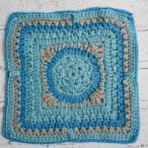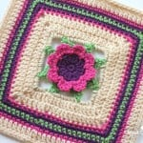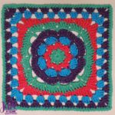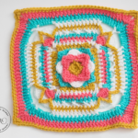

Eligibility: All area residents, young and old, are eligible to enter. You may enter as many squares as you like.
Criteria for Entries:
1. All entries must be clean and smoke/perfume free.
2. The yarn used must be acrylic, worsted weight and any colour of your choice.
3. The square should be blocked and measure 12-inches square when completed.
4. Entries must be primarily crocheted, but other fiber, needle and crafting arts may be incorporated in your design. The overall impression must be crochet.
How to Enter:
- Print your name, address and phone number on a piece of paper or card and attach this to your crocheted square.

- Your entry(s) can be taken to the home of Julie Kimpel at 176 Hope St. E in Tavistock. Phone (519)590-1617 or

- Call Janet Heinbuch at (519)273-4327 to make other arrangements for pick-up.

- All entries must be submitted by March 31, 2022.

- All entries become property of the Tavistock Agricultural Society.

The desire to create is one of the deepest yearnings of the human soul
~Elder Uchtdorf

